Screenshots

1. Resource Group – JgrN

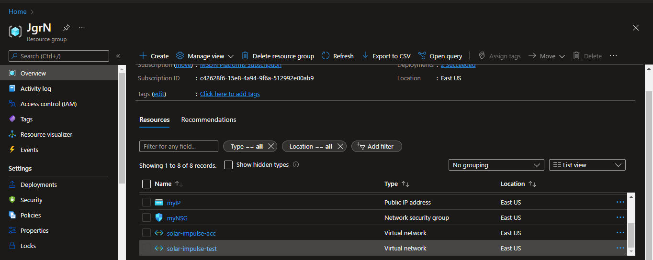

1. **Vnets and Peerings**

**solar-impulse-test**

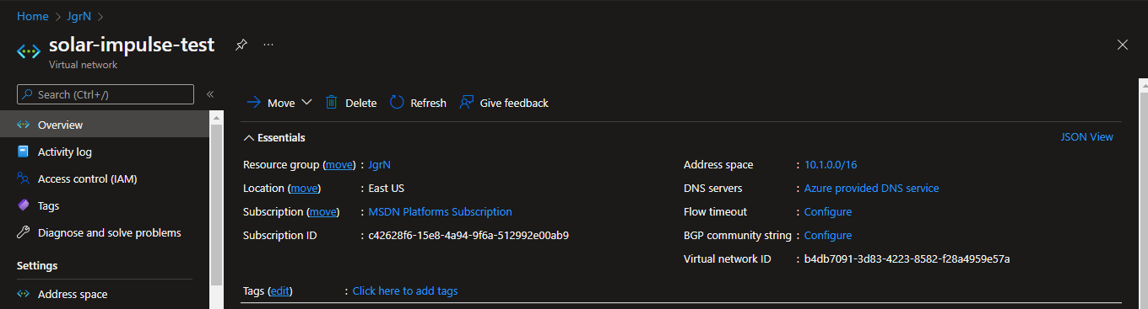

Peering

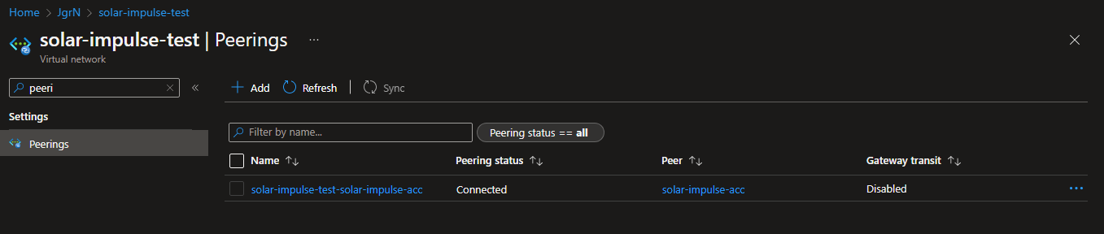

solar-impulse-acc

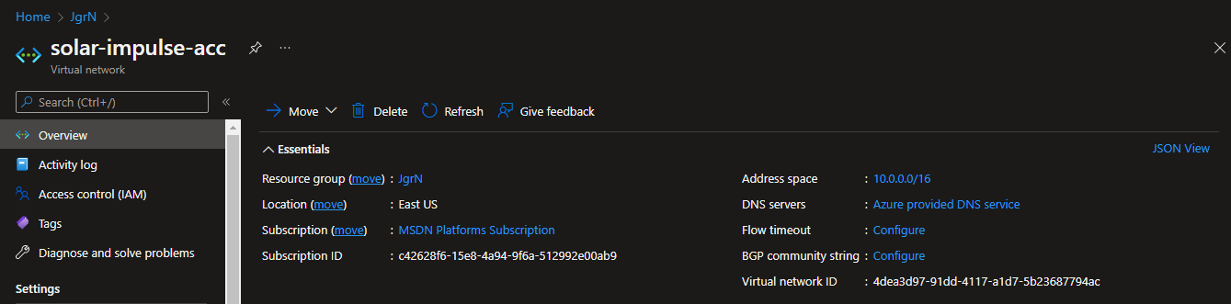

Peering

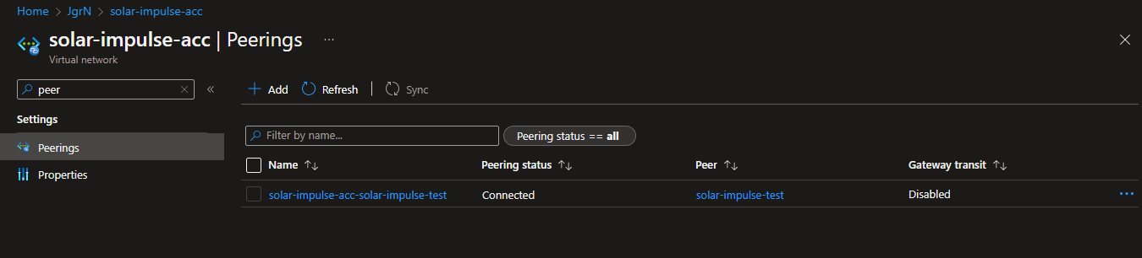

1. Azure Container Instance with Docker image based on official dnsmasq docker image with configuration: server=8.8.8.8 server=8.8.4.4.

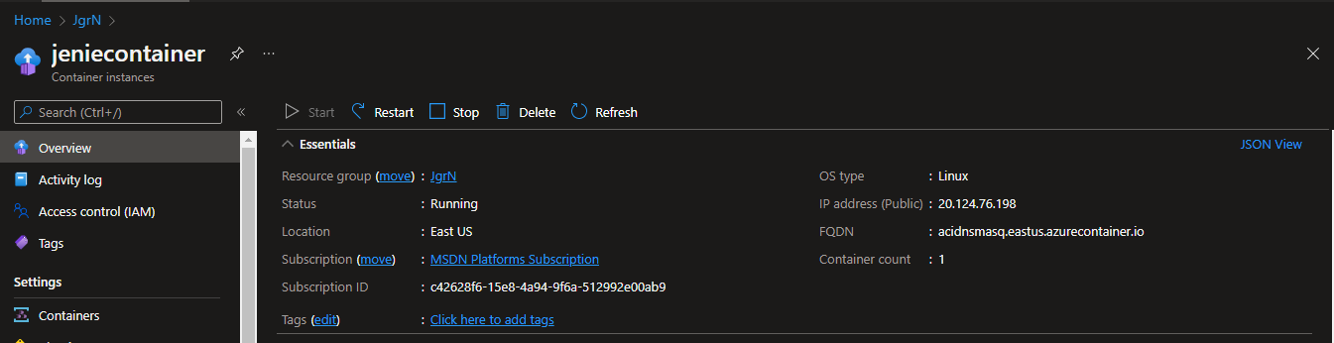

1. Virtual Machine with Static Public IP and password authentication type.

